Gas Filling Station CRM using Salesforce

The **Gas Filling Station CRM** is a custom Salesforce application built to streamline and automate the operations of gas filling stations, specifically in sectors dealing with LPG, CNG, petrol, or diesel distribution. It is used in gas stations where fuel inventory must be monitored, suppliers coordinated, and customer transactions recorded. This CRM helps station managers and staff to manage fuel supply chains, track buyer purchases, calculate payments, and ensure fuel stock is maintained properly. The application is typically used by gas station owners, operators, inventory managers, and customer service agents who rely on accurate, real-time data to make daily operational decisions.

The system is implemented using Salesforce's declarative tools and is built around four main custom objects: **Supplier**, **Gas Station**, **Buyer**, and **Fuel Details**. Each module is connected via relationships to track how much fuel is supplied, where it’s stored, and how it’s consumed. It uses **formula fields** to calculate Fuel Available, **roll-up summaries** to compute totals, and **validation rules** to maintain data integrity. The CRM is accessed through a custom Lightning App, providing users with tailored tabs, page layouts, and reports. It is actively used during fuel order intake, delivery tracking, buyer billing, and inventory review—making it an essential tool for gas station workflow optimization and decision-making.

Project Overview:

The GAS Filling Station *CRM* project is a cloud-based Salesforce CRM application developed to streamline and manage the operations of a gas filling station. The system is designed to handle supplier relationships, monitor gas station fuel inventory, manage buyer transactions, and track the distribution of fuel. It ensures real-time stock updates, automation of billing, and smooth end-to-end operations. This CRM helps gas station managers and employees work efficiently by automating calculations and improving data accuracy.

Objectives:

* To manage suppliers and track total fuel supplied.
* To monitor station-wise fuel inventory and availability.
* To track buyer fuel consumption and automate billing calculations.
* To automate processes such as rollups, formulas, and validations.
* To generate dashboards and reports for station analysis and insights.
* To improve operational efficiency and minimize manual errors.

Requirement Analysis and Planning:

###### **Understanding Business Requirements:**

The gas station requires a system to monitor the inflow and outflow of fuel.

* Suppliers should be tracked with the quantity they supplied.
* Buyers’ transactions need to be recorded, including vehicle type and mode of payment.
* Managers need to view available stock, station usage, and top customers.

###### **Define Project Scope and Objectives:**

* Build a Salesforce CRM with 4 key custom objects.
* Enable automatic fuel tracking via roll-up and formula fields.
* Implement automation for accurate real-time reporting and stock alerts.
* Simplify buyer billing and fuel tracking using formula-based logic.

###### **Design Data Model and Security Model:**

* Custom objects: Supplier, Gas Station, Buyer, Fuel Details
* Relationships:
  + Fuel Details → Master-Detail to Supplier and Gas Station
  + Buyer has standalone tracking, connected via Fuel Filled
* Field-level security enabled based on user roles (manager, staff)

Salesforce Development - Backend and Configuration:

###### **Environment Setup and Devops Workflow:**

* Project built on Salesforce Developer Org.
* Development done in sandbox environment with manual deployment.

###### **Custom Objects and Fields:**

#### 1. Fuel_Details__c

The **Fuel_Details** object serves as the core transactional module in the Gas Filling Station CRM, capturing every instance of fuel movement between suppliers, stations, and buyers. It records key data such as the quantity of fuel supplied (Fuel Supplied), along with associated Supplier Name and Gas Station, both linked through **Master-Detail relationships**. This object enables roll-up summaries at the supplier and station levels for real-time tracking of fuel distribution. It plays a critical role in connecting supply-side data with usage and billing, ensuring transparent and accurate monitoring of fuel flow across the system.

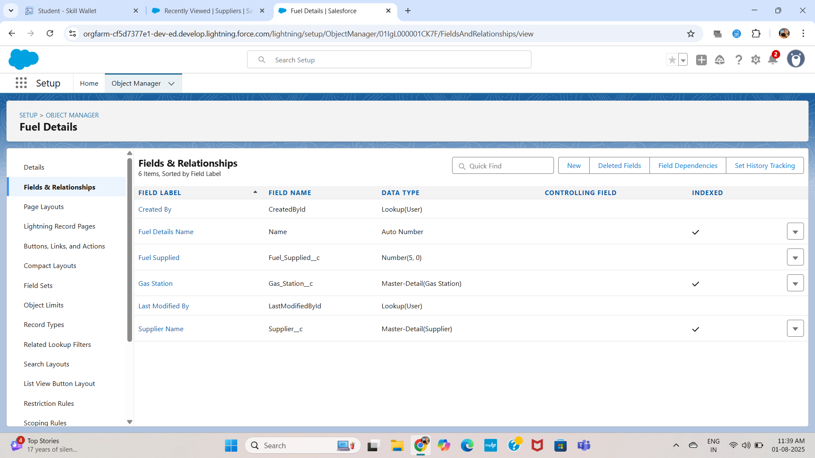

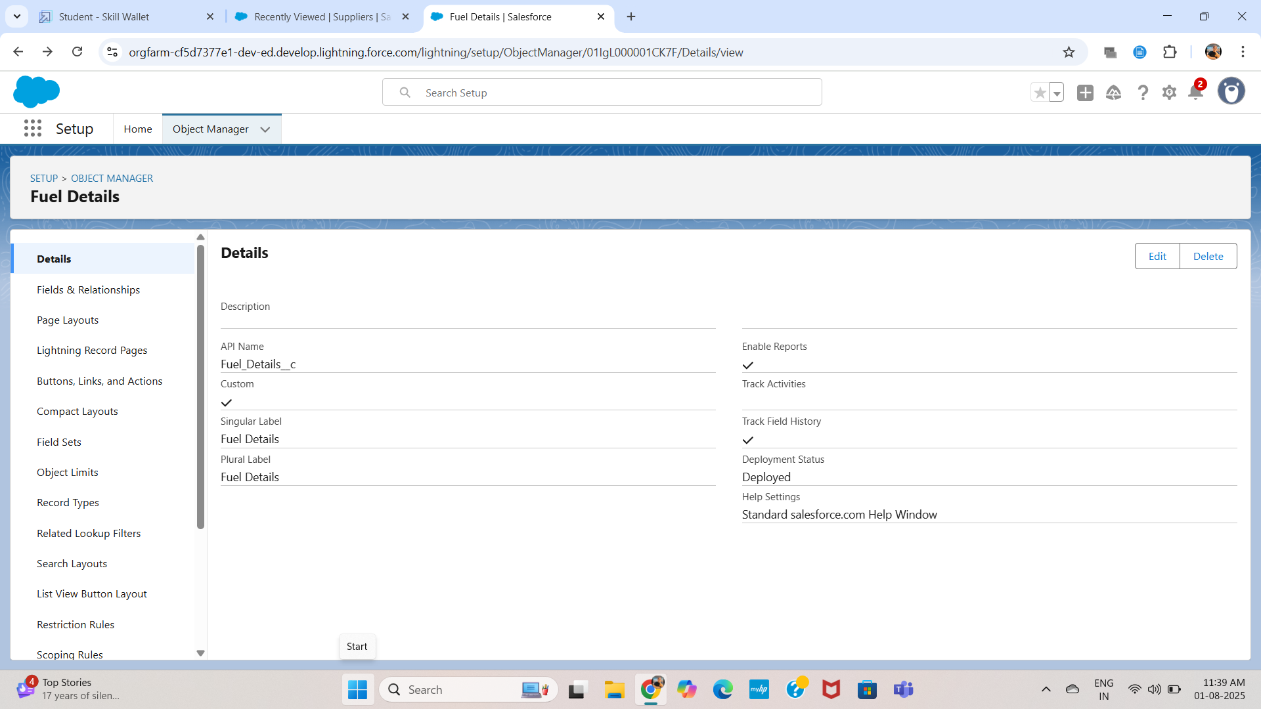

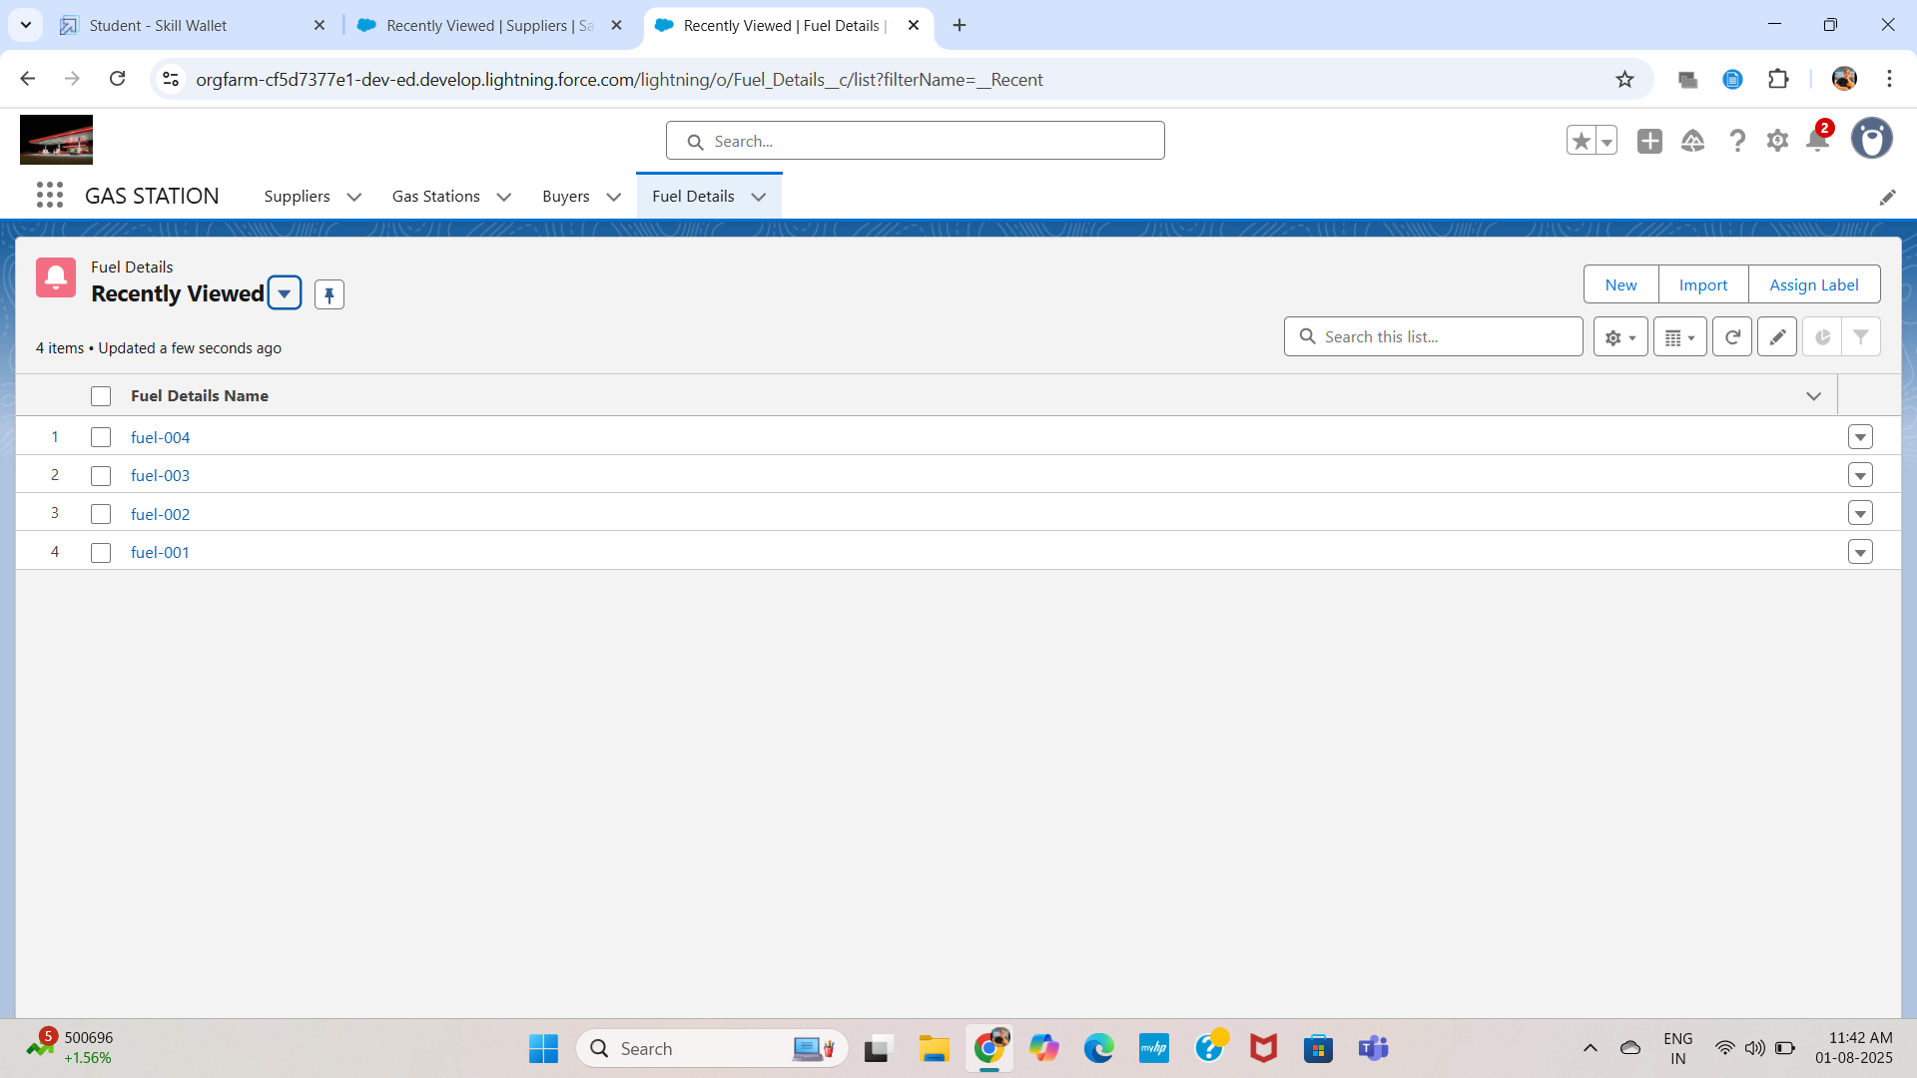

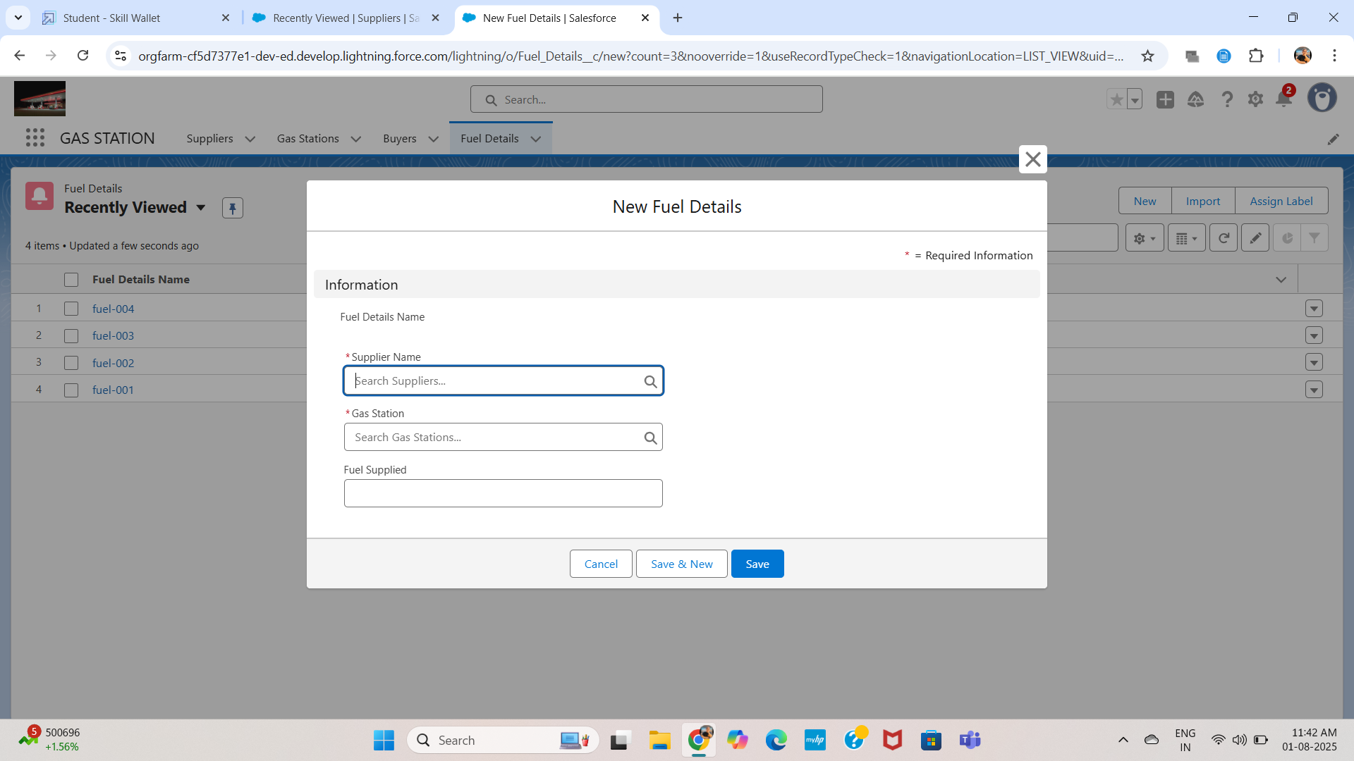

* Fuel_Supplied__c – Number
* Supplier_Name__c – Master-Detail (Supplier)
* Gas_Station__c – Master-Detail (Gas Station)

The **Fuel_Details** object is the central transactional component in the Gas Filling Station CRM, used to record each instance of fuel supplied to a gas station. While creating this object, essential fields such as Fuel_Supplied (Number) were added to capture the quantity of fuel being transferred. To ensure relational integrity and data traceability, two **Master-Detail relationships** were created — one with the Supplier object (Supplier_Name) and another with the Gas Station object (Gas_Station). These relationships allow the CRM to roll up the total amount of fuel supplied per supplier and per station using roll-up summary fields. This setup ensures that every fuel entry is tied directly to both the supplier who provided it and the station that received it, enabling accurate fuel tracking and seamless reporting. The Fuel_Details object acts as a bridge connecting supply chain data with inventory and customer consumption metrics.

#### 2. Supplier__c

* Supplier_Name__c – Text
* Sum_of_Fuel_Supplied__c – Roll-up Summary (Total from Fuel_Details)

The **Supplier** object is designed to manage and track all fuel suppliers associated with the gas filling stations. It stores critical information such as the Supplier Name (Text), Location, Contact Number, and other basic details required for communication and reference. To capture the total quantity of fuel supplied by each supplier, a **Roll-Up Summary** field named Sum of Fuel Supplied was created. This field aggregates data from related Fuel_Details records through the Master-Detail relationship established between Fuel_Details and Supplier. This relationship ensures that for every fuel transaction recorded, the corresponding supplier’s contribution is automatically tracked and summarized. By maintaining this link, the system allows station managers to evaluate supplier performance, monitor delivery volumes, and ensure timely restocking based on historical data.

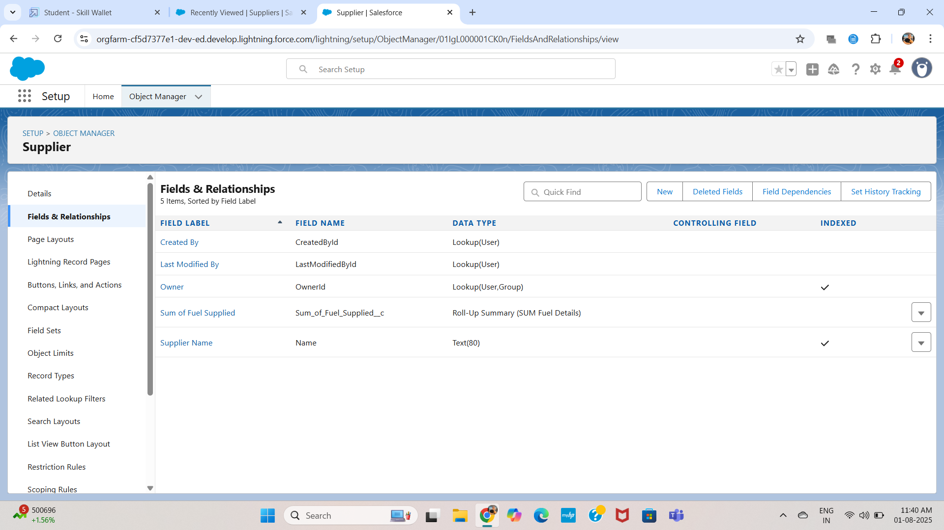

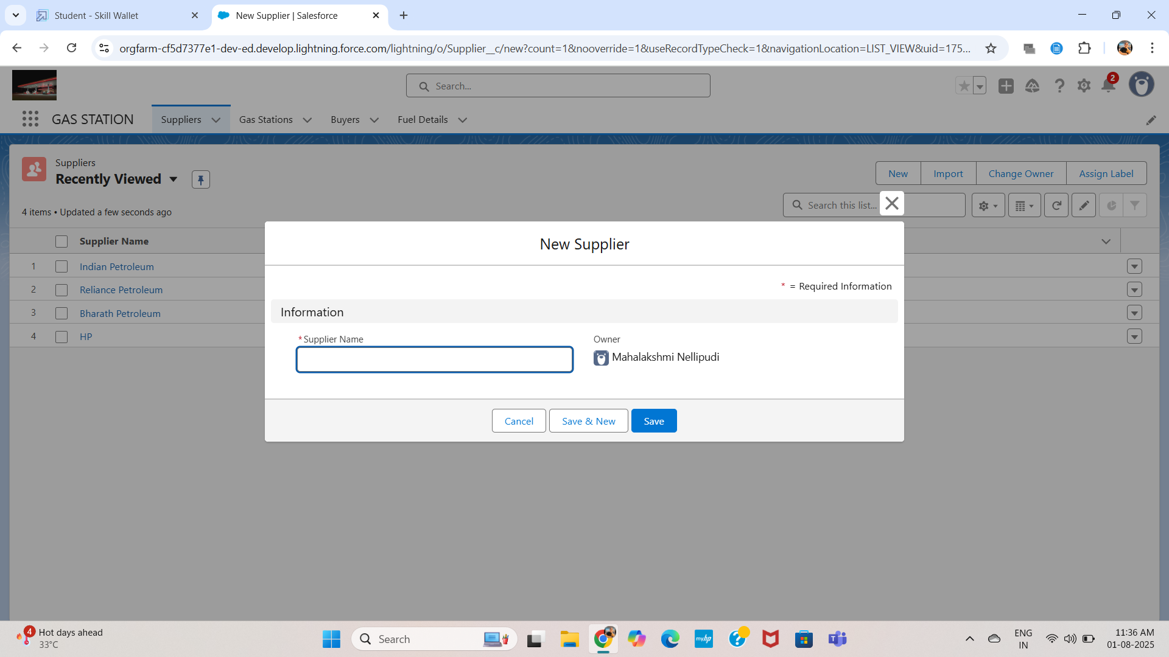



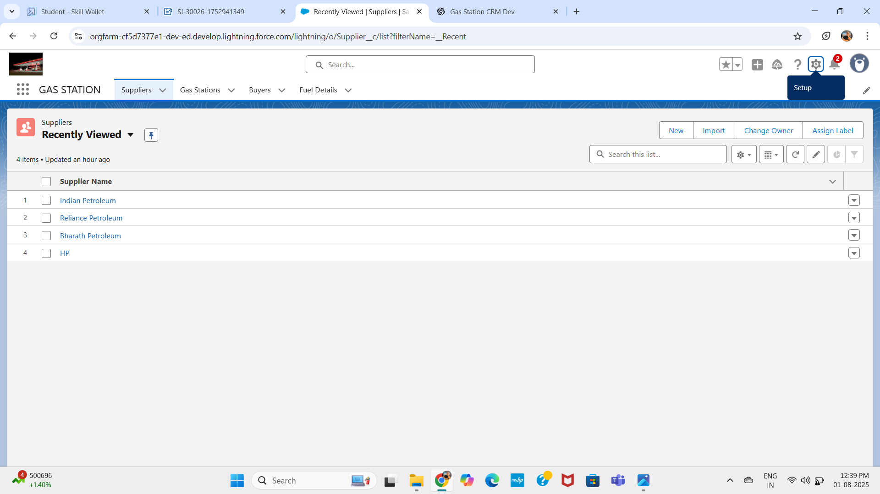

3. Gas_Station__c

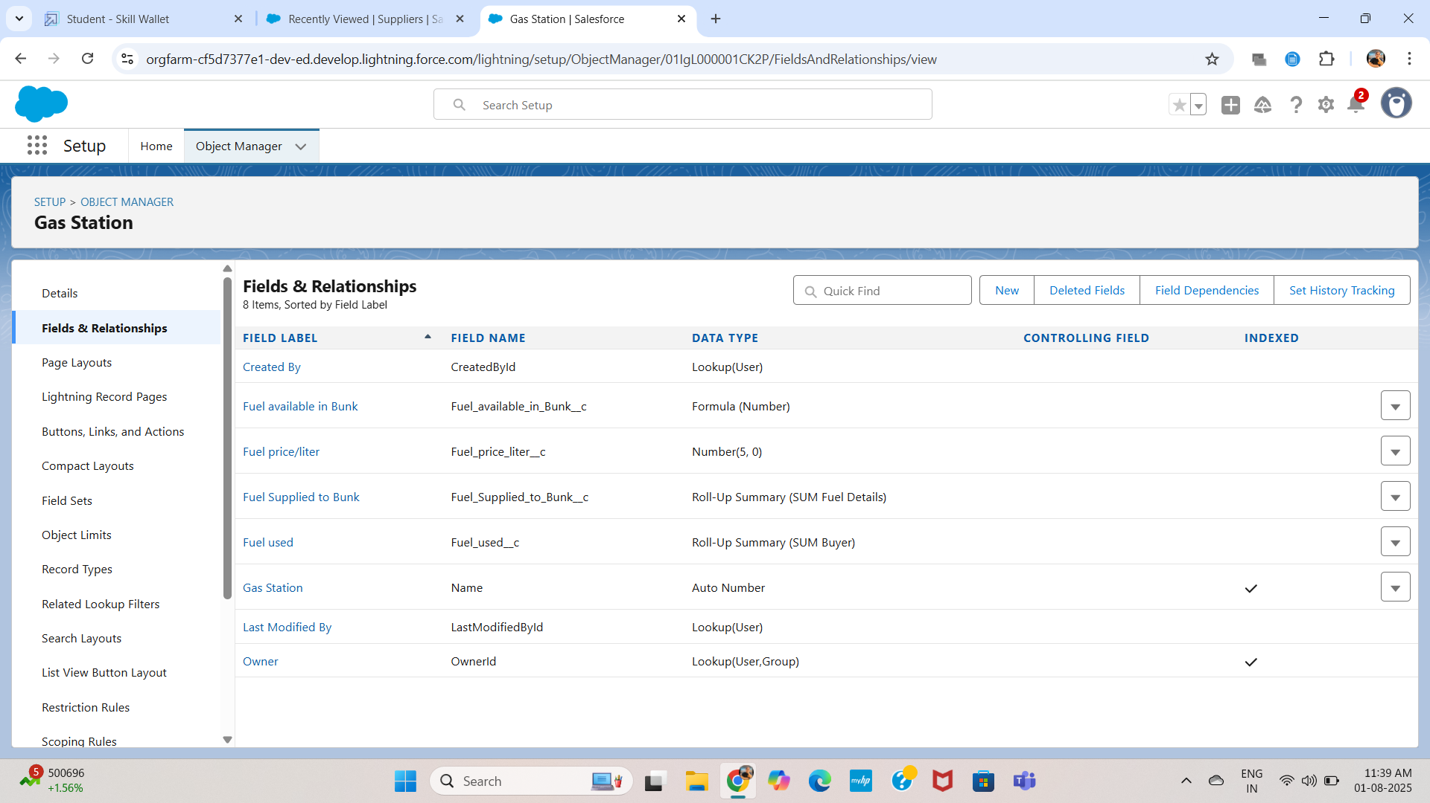

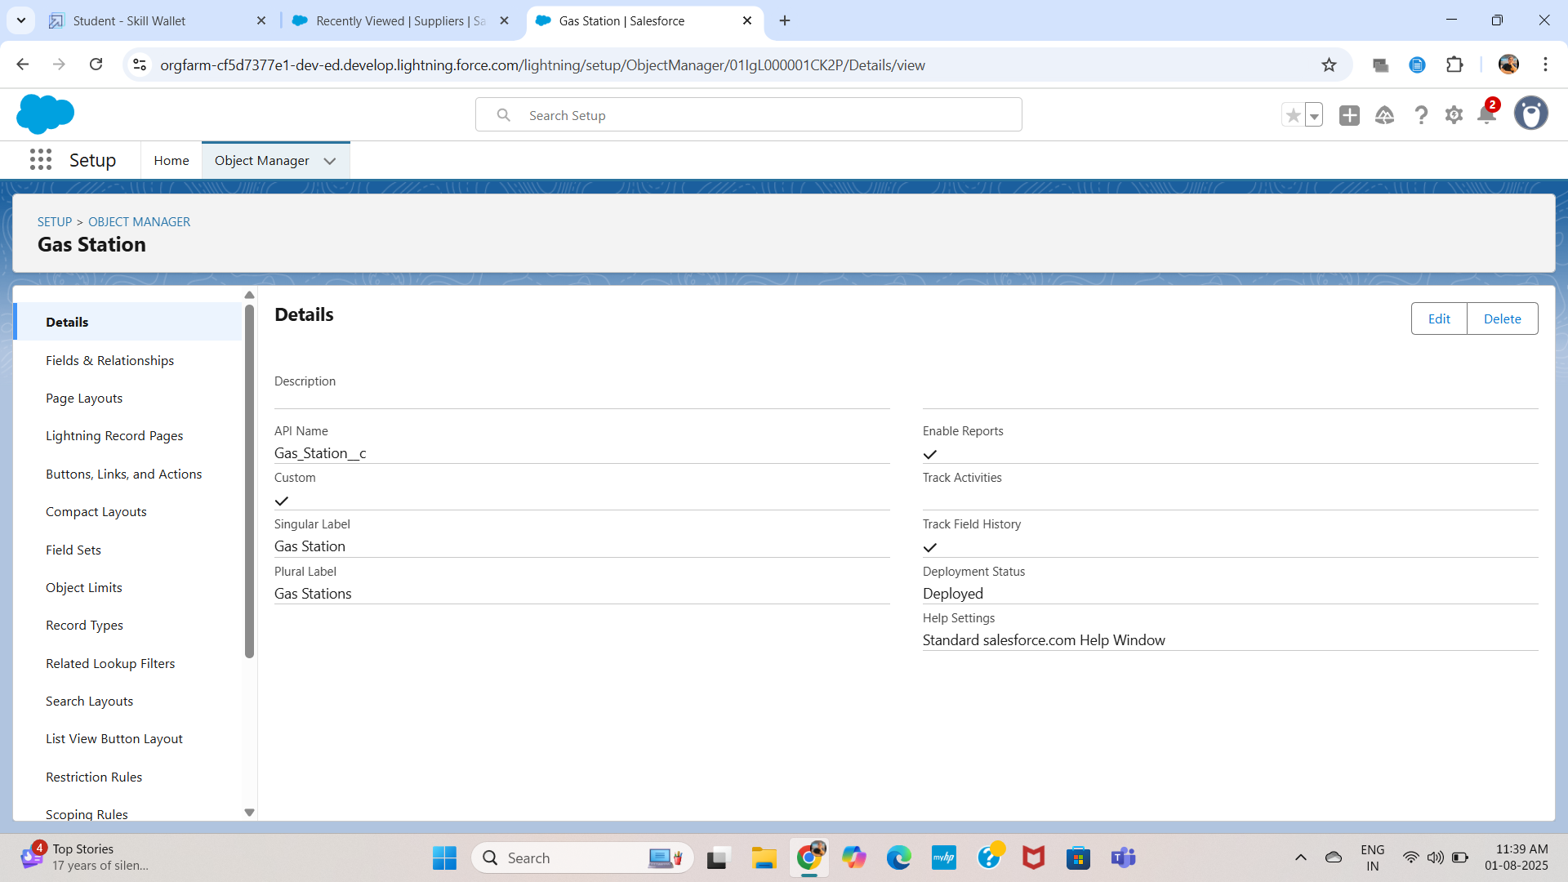



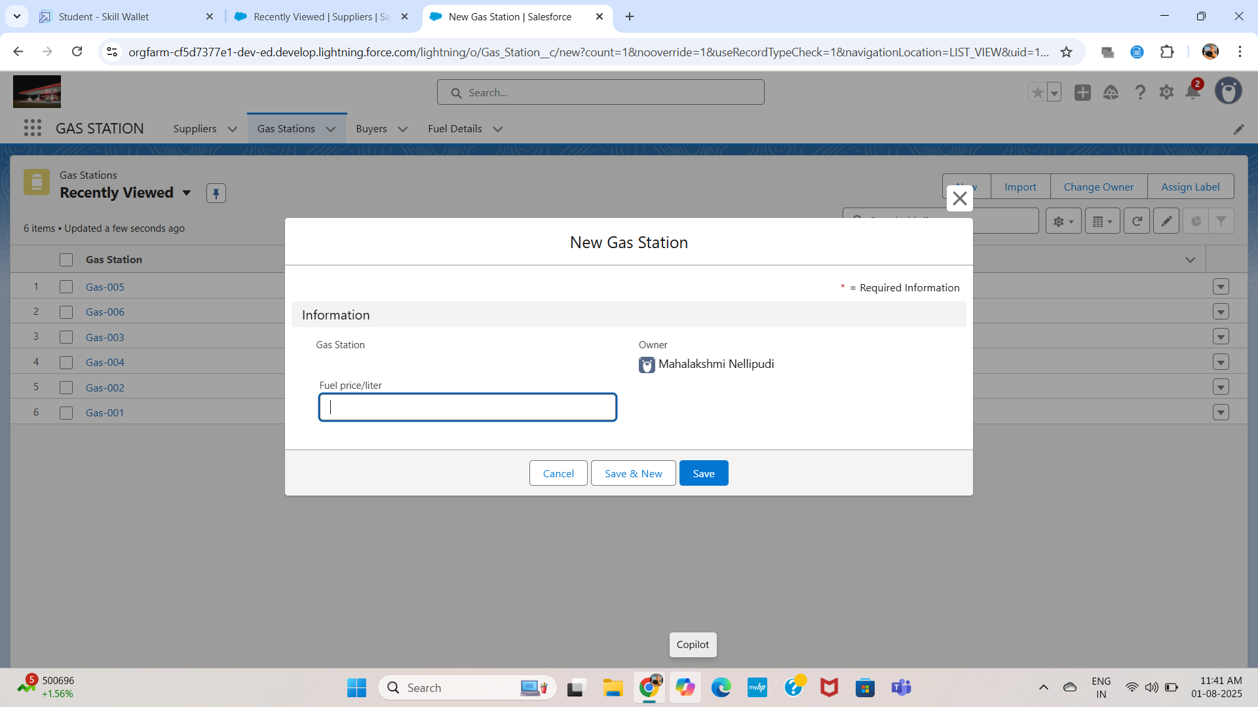

* Gas_Station_Name__c – Text
* Fuel_Supplied_to_Bunk__c – Roll-up Summary (from Fuel_Details)
* Fuel_Price_per_Litre__c – Number (Length: 5)
* Fuel_Used__c – Roll-up Summary (from Buyer)
* Fuel_Available_in_Bunk__c – Formula: Fuel_Supplied_to_Bunk - Fuel_Used

The **Gas Station** object stores details of each station, including Gas Station Name, Fuel Price per Litre, and its operational status. It has a **Master-Detail relationship** with the Fuel_Details object to track fuel received. A **Roll-Up Summary** field, Fuel Supplied to Bunk, calculates total fuel received, while Fuel Used summarizes fuel dispensed to buyers. A **Formula Field**, Fuel Available in Bunk, computes available stock by subtracting used fuel from the supplied amount, enabling efficient inventory tracking.

4. Buyer__c

* First_Name__c – Text
* Last_Name__c – Text
* Customer_Name__c – Formula: First_Name + ' ' + Last_Name
* Phone_Number__c – Phone
* Email__c – Email
* Fuel_Filled_in_Vehicle__c – Number (Length: 5)
* Vehicle_Type__c – Picklist: Two wheeler, Three wheeler, Four wheeler, Six wheeler, Eight wheeler, Others
* Mode_of_Payment__c – Picklist: Credit Card, Debit Card, Net Banking, UPI, Cash
* Amount_Paid__c – Formula: Fuel_Filled * Fuel_Price_per_Litre

The **Buyer** object is used to record customer details and fuel purchase information. It includes fields such as First Name, Last Name, Phone Number, and Email, with a **Formula Field**Customer Name combining the first and last names for display.

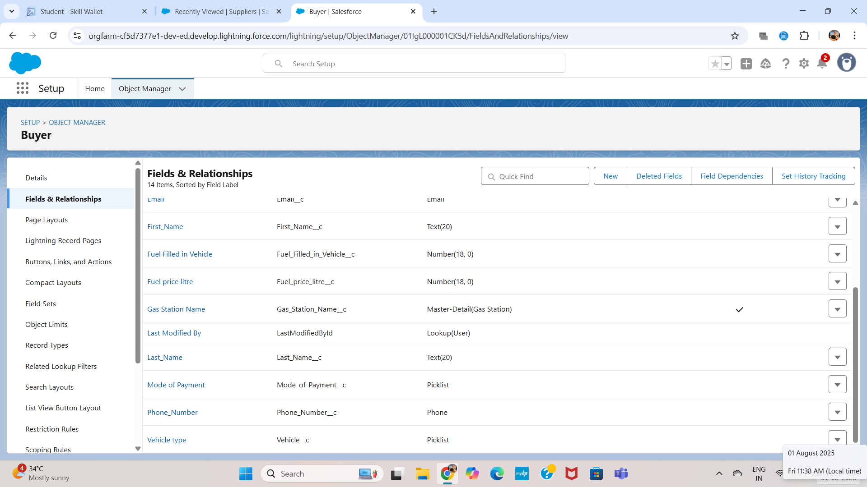





###### 

###### 

###### 

###### **Validation Rules:**

* Prevent negative fuel entries.
* Ensure valid combinations of fuel quantity and amount.

###### **Automation Tools Used:**

* Roll-up Summary Fields
* Formula Fields
* No Apex used

UI/UX Development and Customization:

* **Lightning App** created via App Manager: *Gas Station CRM App*
* **Page Layouts** customized for all 4 objects.
* **Dynamic Forms** used for Buyer and Gas Station layouts.
* **User Management**: Standard Profiles used, with object/field permissions adjusted.
* **Reports and Dashboards** created:
  + Total Fuel Supplied (Supplier-wise)
  + Fuel Stock Overview (Station-wise)
  + Top Customers by Volume
* **Lightning Pages** designed for a clean layout with tabs and highlights.

As part of the UI/UX development phase, the application’s user interface was designed to be intuitive, organized, and role-friendly using Salesforce Lightning Experience. A **custom app** named *Gas Filling Station CRM* was created using the **App Manager**, bringing all four custom objects—Supplier, Gas Station, Buyer, and Fuel Details—under one streamlined navigation bar for easy access.

Each object was customized with **Lightning Record Pages** that included tabs, highlights panels, and related lists to improve user readability and reduce clutter. **Page Layouts** were configured to display only relevant fields based on the user’s role—for instance, buyers see payment and contact fields, while managers see fuel summaries and stock details.

**Dynamic Forms** were used, particularly in the Buyer and Gas Station objects, to show or hide fields based on field values (e.g., revealing payment fields only when a fuel entry exists). Related lists such as Fuel Details under Supplier and Gas Station were added for relational visibility.

In addition to layouts, **compact layouts** were configured to show key fields like Customer Name, Phone, and Fuel Filled when records are viewed in list view or mobile. The UI ensures that both technical and non-technical users can interact with the system efficiently, without needing backend knowledge.

This customized interface enhances usability, speeds up data entry, and supports error-free operations by surfacing only relevant data at each step.

The **user interface and user experience (UI/UX)** of the Gas Filling Station CRM was carefully designed using Salesforce Lightning to ensure the system is user-friendly, clean, and efficient for all roles interacting with the application. A **custom Lightning App** named *Gas Filling Station CRM* was created using the App Manager, grouping all four custom objects—**Supplier, Gas Station, Buyer, and Fuel Details**—into a single accessible tabbed interface. This helped in logically organizing the CRM layout and made navigation easy for users like station managers, staff, and admins. Each object had its own **Lightning Record Page** with well-defined sections, related lists, and highlights panels to emphasize key fields like fuel quantities and payment information.

**Dynamic Forms** were implemented on the **Buyer** and **Gas Station** objects to display specific fields based on user inputs—for example, the Amount Paid field only appears after fuel quantity is entered. This reduces confusion and improves data accuracy. Custom **Page Layouts** were configured per profile to show or hide fields based on roles (e.g., fuel stock and summary fields for managers only). **Compact Layouts** were also created to display important fields like Customer Name, Fuel Filled, and Phone Number in search results and list views, improving at-a-glance usability. Additionally, **Related Lists** were added across objects to provide quick insights into associated records—such as all Fuel Details associated with a specific supplier or station. The UI is optimized not only for desktop use but also for mobile access using the Salesforce mobile app, ensuring flexibility and real-time updates from any device.

Data Migration, Testing and Security:

* **Data Loading** via Data Import Wizard for test data of all objects.
* **Field History Tracking** enabled on Fuel_Supplied, Fuel_Available_in_Bunk.
* **Profiles and Roles**: Simple hierarchy — Admin, Station Manager, Staff
* **Permission Sets** assigned for object access during testing.
* **Test Cases**:
  + Creation of Fuel Details with valid supplier/station
  + Buyer record with amount auto-calculated
  + Validation for negative fuel quantity fails
  + Dashboard displays correct data after entry

Deployment, Documentation and Maintenance:

* **Deployment Strategy**: Manual setup in Dev Org; ready for Change Set migration
* **Maintenance Plan**:
  + Weekly review of object data
  + Monthly performance review through dashboards
  + Field additions and formula tweaks as per future needs
* **Troubleshooting**:
  + Issues tested via debug logs and field history
  + Validations tested with both valid and invalid inputs

ScreenCaptures:

Where relevant, you should include screenshots of the following:

* **Object Manager:** showing each custom object (Supplier, Gas Station, Buyer, Fuel Details)
* **Field Definitions:** custom fields, formulas, and picklists
* **Page Layouts & Lightning Pages**
* **Roll-Up Summary Configuration**
* **Formula Field Editor (e.g., Fuel Available in Bunk)**
* **Validation Rules**
* **Reports & Dashboards Overview**

Automation Features:

The Gas Filling Station CRM includes several automation features designed to improve efficiency, accuracy, and real-time data tracking. **Roll-Up Summary Fields** are used extensively to calculate the total fuel supplied by each supplier and the total fuel received by each gas station. A **formula field** automatically computes the Fuel Available in Bunk by subtracting fuel consumed from fuel supplied. In the Buyer object, the Amount Paid is calculated using a formula based on the quantity of fuel filled and the station’s price per litre. **Validation rules** ensure that negative fuel values cannot be entered and that necessary picklist values like vehicle type and payment mode are selected. These declarative automation tools reduce manual calculations, enforce data integrity, and streamline the entire fuel supply and billing workflow.

|  |  |
| --- | --- |
| Feature | Description |
| **Validation Rules** | Ensure no negative Quantity is entered, and picklists are selected properly |
| **Formula Fields** | Calculate values such as Amount Paid, Fuel Available in Bunk, and Customer Name. |
| **Roll-up Summary** | Used to compute totals like Sum of Fuel Supplied, Fuel Used, etc., across relationships. |

***Testing Approach:***

The testing phase of the Gas Filling Station CRM focused on verifying data accuracy, automation logic, field validations, and report integrity. Manual testing was performed by creating test records for all custom objects—**Supplier**, **Gas Station**, **Buyer**, and **Fuel Details**—to ensure that relationships and field-level calculations worked correctly. Specific scenarios were tested, such as calculating Amount Paid in the Buyer object, updating Fuel Available in Bunk based on fuel usage, and validating proper roll-up summaries for fuel supply. **Validation rules** were tested by attempting to enter invalid data, such as negative fuel values or missing picklist selections. Reports were reviewed after data entry to ensure charts reflected accurate and up-to-date values. Overall, this functional testing ensured the CRM worked as intended before deployment.The testing process for the Gas Filling Station CRM involved thorough manual validation to ensure the correctness of functionality, data flow, and automation logic across all custom objects. Each module—**Supplier**, **Gas Station**, **Buyer**, and **Fuel Details**—was tested independently and in integration with related objects.

|  |  |  |
| --- | --- | --- |
| Test Case | Input | Expected Output |
| Create Fuel Detail Record | Valid Supplier, Station, Quantity | Record created; roll-up updates correctly |
| Add Buyer Record | Fuel Quantity = 50L | Amount Paid auto-calculated using fuel price |
| Try invalid quantity | Fuel Quantity = -10 | Error displayed (Validation Rule) |
| Report Check | Create records, view dashboard | Charts reflect latest records |

Future Enhancements:

To make the Gas Filling Station CRM more robust and intelligent, several future enhancements can be implemented. Integration with **payment gateways** (such as Razorpay or Paytm) can allow real-time payment processing directly within the CRM. Adding **SMS and email notifications** can alert station managers when fuel stock is low or when a new order is placed. A **mobile-friendly interface** using the Salesforce mobile app can enable on-the-go access for delivery staff and station operators. Further, the inclusion of **AI-based analytics** can help predict fuel demand based on historical trends, improving stocking decisions. Additionally, a **chatbot integration** could assist customers in checking their transaction history or booking fuel refills through simple queries, enhancing user experience and automation.

|  |  |
| --- | --- |
| Enhancement Area | Description |
| **Chatbot Integration** | Help customers with booking refills and FAQs |
| **AI Suggestions** | Predict fuel demand based on usage trends |
| **SMS Integration** | Alert station managers when stock goes low |
| **Mobile App Access** | Enable mobile tracking for managers and buyers |
| **Payment Gateway** | Link buyer payments with UPI or online billing directly |

Reports:

###### **Purpose of reports:**

Reports in the Gas Filling Station CRM provide real-time visibility into essential business data such as fuel supply, buyer transactions, and station-level inventory. These reports are designed to help station managers and business stakeholders make data-driven decisions, monitor operations, and ensure transparency in the supply and usage of fuel.

#### 1. Fuel Supplied – Supplier-wise Report

* **Object**: Fuel_Details
* **Group By**: Supplier Name
* **Fields Included**: Fuel Supplied, Gas Station, Date
* **Use**: Helps track how much fuel each supplier has provided to different gas stations.

#### 2. Fuel Supplied to Each Gas Station

* **Object**: Fuel_Details
* **Group By**: Gas Station Name
* **Fields Included**: Fuel Supplied, Supplier Name, Date
* **Use**: Allows station managers to see total incoming fuel at their station for a specific period.

#### 3. Fuel Filled by Buyers

* **Object**: Buyer
* **Fields Included**: Customer Name, Fuel Filled in Vehicle, Vehicle Type, Phone Number
* **Use**: Helps identify how much fuel has been consumed by each buyer; useful for customer insights.

#### 4. Payment Collection Report

* **Object**: Buyer
* **Fields Included**: Customer Name, Fuel Filled, Amount Paid, Mode of Payment
* **Use**: Useful to track revenue generated and to analyze payment preferences across buyers.

#### 5. Vehicle Type Analysis Report

* **Object**: Buyer
* **Group By**: Vehicle Type
* **Fields Included**: Fuel Filled, Amount Paid
* **Use**: Analyzes which types of vehicles consume the most fuel — helpful for marketing or stocking decisions.

#### 6. Mode of Payment Report

* **Object**: Buyer
* **Group By**: Mode of Payment
* **Fields Included**: Customer Name, Fuel Filled, Amount Paid
* **Use**: Monitors buyer payment trends and helps identify popular payment channels (e.g., UPI, Cash, Credit Card).

Dashboard:

###### **Purpose of Dashboard:**

Dashboards in the Gas Filling Station CRM provide a **visual representation** of key performance metrics drawn from reports. They help users quickly interpret fuel-related data, track inventory levels, monitor buyer activity, and assess supplier performance. Dashboards enable real-time insights for managers, reduce the need for manual tracking, and support better operational decisions.

###### **Benefits of Dashboard:**

* Saves time by providing at-a-glance analytics.
* Encourages data-driven decisions for stock refilling and supplier management.
* Identifies sales and revenue trends without manual calculations.
* Provides actionable insights to improve customer service and fuel distribution.

###### **Sample Dashboard:**

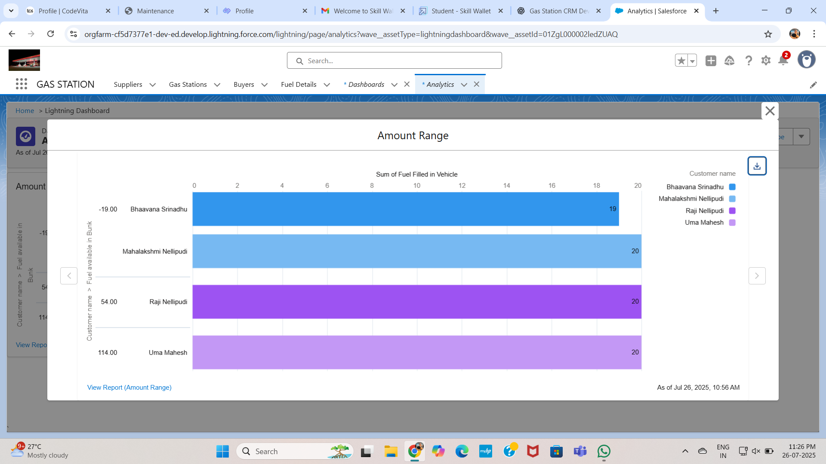

Creating custom objects:

In the Gas Filling Station CRM, **custom objects** were created to model the core entities of the business process—namely, **Supplier**, **Gas Station**, **Buyer**, and **Fuel Details**. These objects were created through the **Object Manager** in Salesforce Setup, where each object was defined with its label, API name, optional features like record name settings, and object-level permissions. During creation, options such as **Allow Reports**, **Track Field History**, and **Allow Activities** were enabled where necessary to support reporting, tracking changes, and task management. Custom fields were added to each object to capture specific data like fuel quantity, vehicle type, payment mode, and pricing. Relationships were established using **Master-Detail** and **Lookup fields**, enabling roll-up summaries and enforcing data integrity across objects. Creating these custom objects allowed for a fully tailored data model that fit the specific needs of a gas filling station, ensuring the system could support inventory tracking, customer transactions, and supplier management effectively.

In the Gas Filling Station CRM, custom objects were created to represent the core entities of the business: **Supplier**, **Gas Station**, **Buyer**, and **Fuel Details**. These objects were designed using Salesforce's Object Manager, allowing complete customization of fields, relationships, and behaviors. During creation, options like **Allow Reports**, **Track Field History**, and **Allow Activities** were enabled where necessary to enhance usability and ensure traceability. Each object was given a clear label, object name, and custom icon for better UI navigation. The structure of each object was aligned with the business logic of a real-world gas filling station workflow—from receiving fuel from suppliers to distributing it to buyers.

Custom fields such as Fuel Supplied, Fuel Price per Litre, Mode of Payment, and Amount Paid were added using appropriate data types like **Number**, **Picklist**, **Formula**, and **Roll-Up Summary**. Relationships were created using **Master-Detail** and **Lookup fields** to maintain data integrity and support automation features. For example, Fuel Details was linked to both Supplier and Gas Station via Master-Detail relationships, allowing roll-up summaries to track total fuel supplied or received. These custom objects formed the backbone of the CRM, providing a fully tailored data model that supports automation, reporting, and security in a real-time, scalable environment.

Creating these custom objects allowed the CRM to reflect the exact operational flow of a gas filling station, rather than relying on generic standard objects. Each object was also enhanced with **custom page layouts** and **compact layouts** to improve user experience. Field-level security and object permissions were configured during creation to ensure data visibility based on user roles. The design was kept flexible to allow future scalability—such as adding new fuel types, expanding buyer categories, or integrating station performance tracking. Overall, the thoughtful planning and configuration of custom objects laid a strong foundation for the entire CRM’s functionality, enabling automation, data consistency, and streamlined processes across the application.

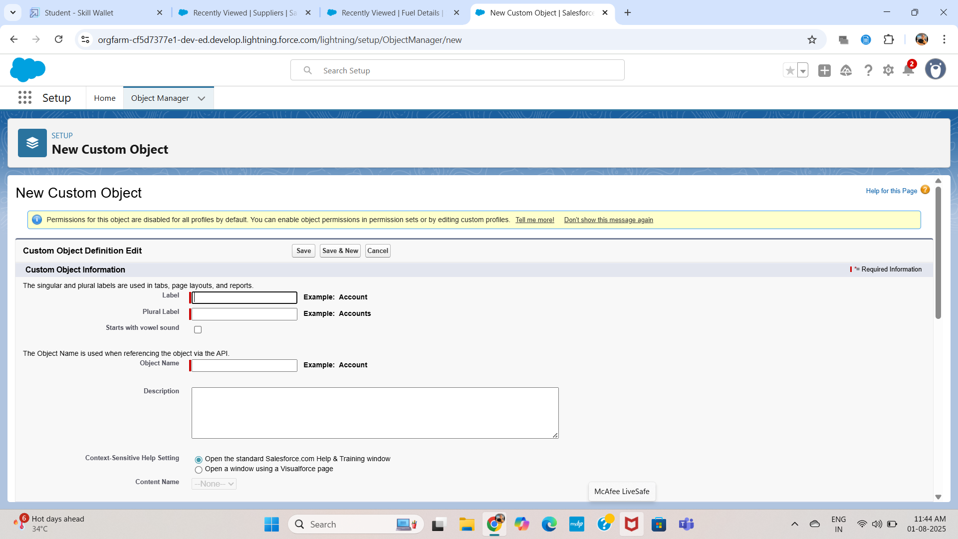

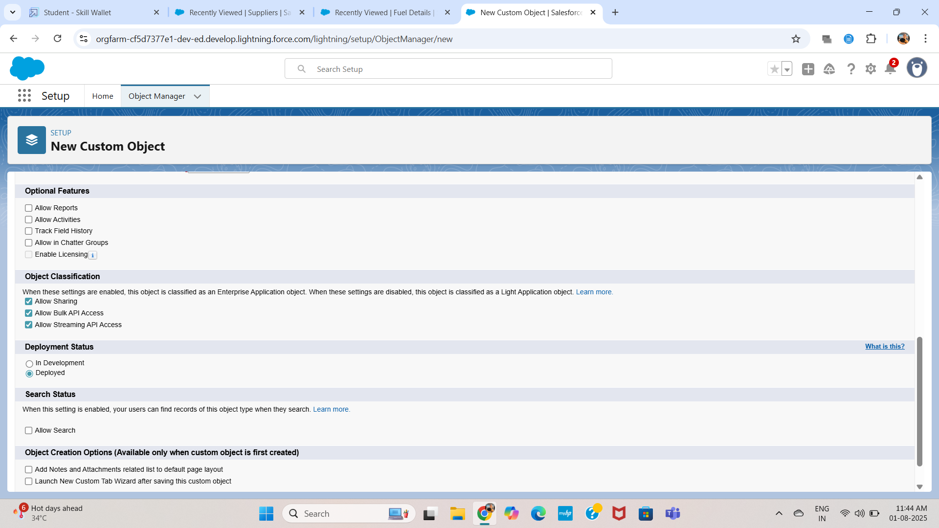

Tabs:

Tabs were created for all four custom objects—**Supplier**, **Gas Station**, **Buyer**, and **Fuel Details**—to make navigation smooth and intuitive within the *Gas Filling Station CRM* Lightning App. Each tab provides direct access to the respective object’s records, enabling users to quickly create, view, and manage data without navigating through complex menus. These tabs were added using the **App Manager** during app setup, ensuring they are visible and accessible from the main app navigation bar. The tabs were ordered logically to reflect the fuel flow process—from supplier to gas station to buyer—which helps users follow a natural workflow. Icons and labels were customized to improve visual recognition, making the interface more engaging. Tab visibility was also controlled based on user profiles, ensuring that each user sees only the relevant modules necessary for their role. This configuration significantly enhanced usability and reduced navigation time within the CRM.

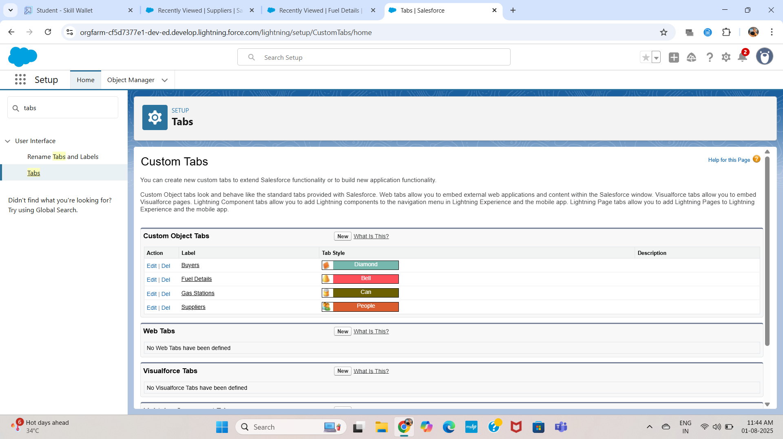

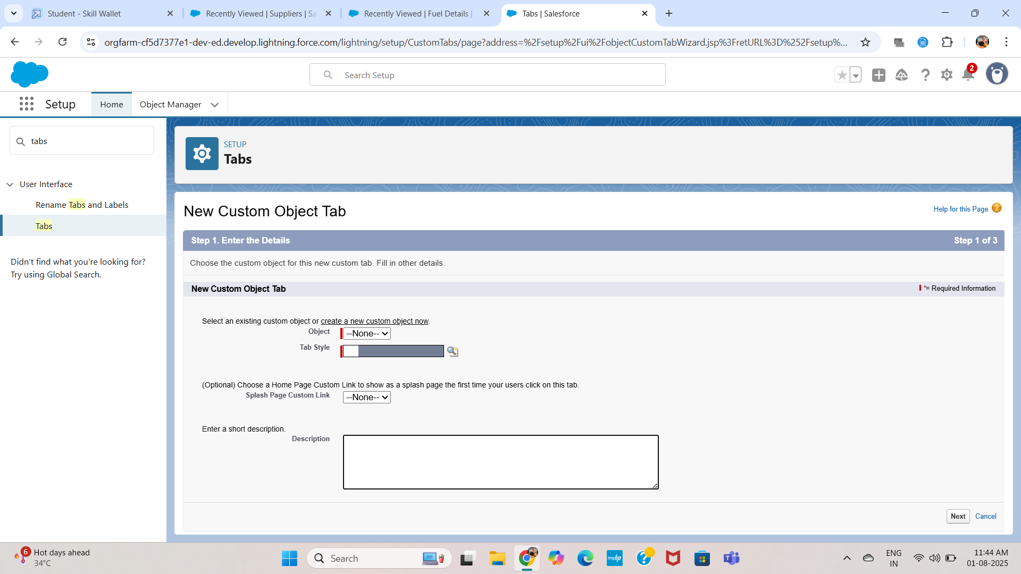

Custom Permissions:

In the Gas Filling Station CRM, **custom permissions** were used to provide granular access control to specific features and functionalities within the application. Custom permissions allow administrators to define access to specific processes—such as viewing sensitive reports, editing fuel pricing, or accessing administrative dashboards—without modifying object- or field-level security directly. These permissions were created in **Setup → Custom Permissions**, and then bundled into **Permission Sets** assigned to different user roles such as Admin, Station Manager, or Staff. By using custom permissions, we ensured that only authorized users could perform critical actions like updating fuel prices or managing supplier records, thereby improving system security and compliance. This approach also enhances flexibility, as permissions can be reused across flows, validation rules, and Apex logic to enforce business rules consistently.

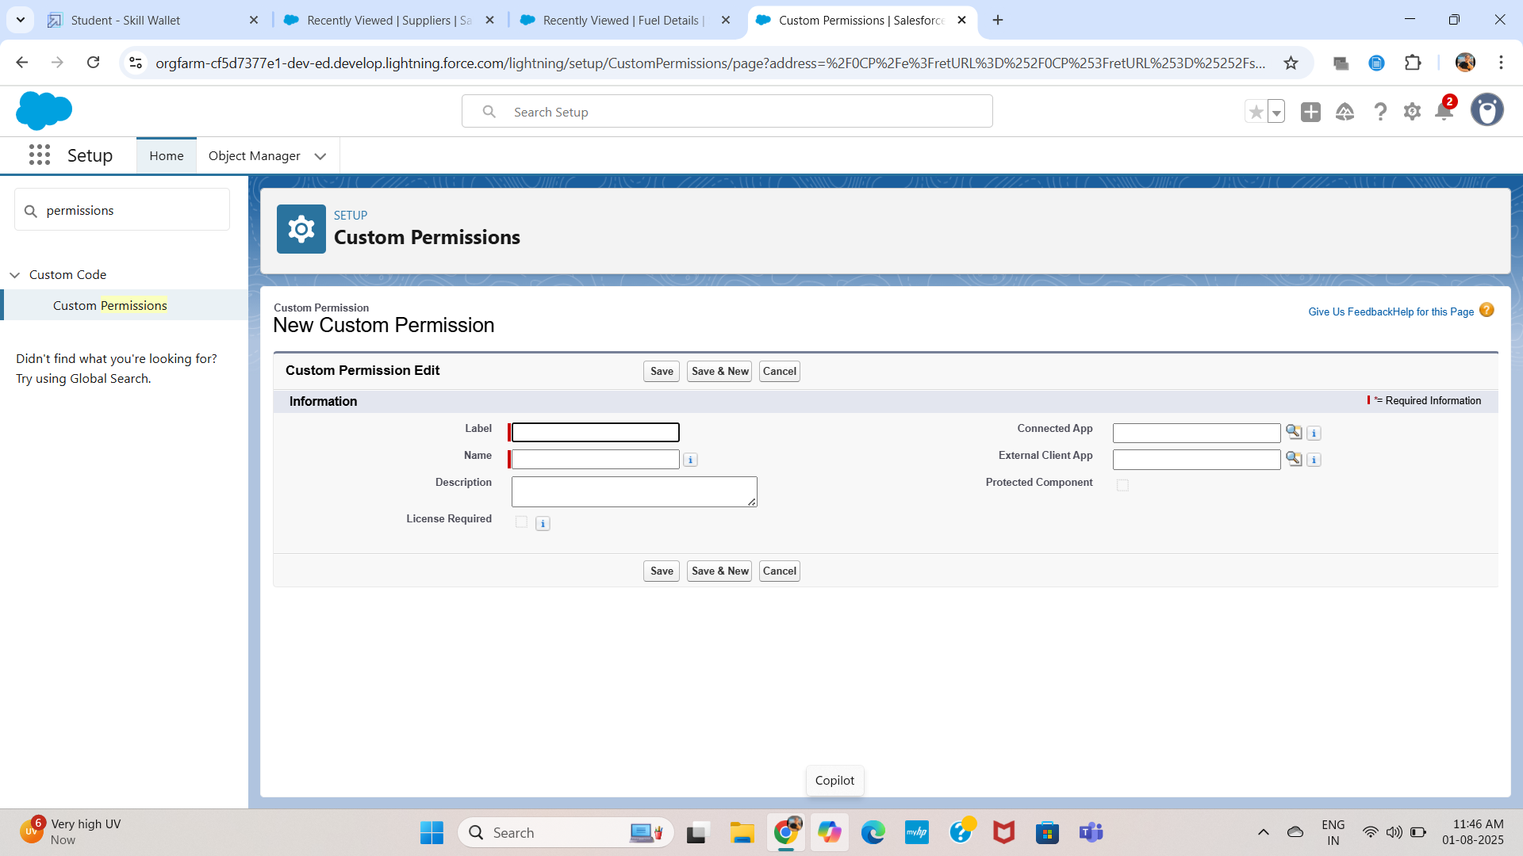

Glossary of terms:

|  |  |
| --- | --- |
| **Term** | **Description** |
| Custom Object | A user-defined object in Salesforce used to store unique data types. |
| Roll-Up Summary | A field that calculates values from child records in a Master-Detail relationship. |
| Formula Field | A read-only field that derives its value from a formula expression. |
| Validation Rule | A rule that prevents users from saving incorrect or invalid data. |
| Master-Detail | A relationship where the child record’s existence depends on the parent. |
| Lookup Relationship | A more flexible relationship where the child can exist independently. |
| Dashboard | A visual representation of report data using charts and graphs. |
| Flow | An automation tool that guides users through processes or handles logic. |
| Permission Set | A Salesforce feature to grant additional permissions to users without changing their profile. |
| Lightning App | A custom app in Salesforce for organizing tabs, pages, and data. |

Conclusion:

The Gas Filling Station CRM built on Salesforce provides a fully integrated and automated solution to manage gas station operations. With real-time tracking of fuel inventory, supplier performance, and buyer transactions, it ensures operational transparency and accuracy. Using native Salesforce tools such as roll-up summaries, formulas, and dynamic forms, the solution was developed without any custom code. It is scalable and ready for enhancements such as mobile support, payment gateway integration, and predictive analytic.